**W6** PRACTICE

*My SQL*

## *At the end of his practice, you should be able to…*

* Establish a **MySQL connection** on the back-end app
* Implement a **repository** layer using **MySQL queries**
* **Test the endpoints** (REST API client + front-end app)
* **Extends the project** to handle **4 tables** in the database

## *How to start?*

* Download **start code** from related MS Team assignment
* Run npm install on both front and back projects
* Run npm run dev on both front and back projects to run the client and the server

## *How to submit?*

* Submit your **code** on MS Team assignment

## *Are you lost?*

*To review MySQL queries syntax*

<https://www.w3schools.com/mysql/mysql_sql.asp>

*To install My SQL Server (if needed)*

<https://dev.mysql.com/doc/refman/8.4/en/windows-installation.html>

<https://dev.mysql.com/downloads/>

*To connect Node back end to MySQL*

<https://www.w3schools.com/nodejs/nodejs_mysql.asp>

<https://sidorares.github.io/node-mysql2/docs/documentation>

# EXERCISE 1 – MySQL **Manipulation**

**Before starting !**

You should have a MySQL Server running. Check it out with bellow command:

mysql -u root -p

You should see MySQL monitor run properly:

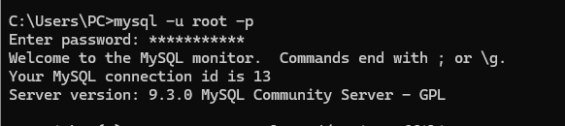

If not, you need to install and configure MySQL server properly.

<https://dev.mysql.com/doc/refman/8.4/en/windows-installation.html>

**Q1 -** **Create the database and the table of articles**

* Open the terminal and launch MySQL monitor:

mysql -u root -p

* Create a new database (e.g. **week6Db**) using the command line
* Create a new table (articles) with the columns below:

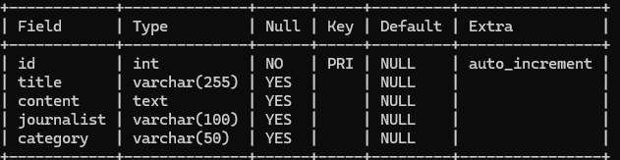

**Q2 -** **Review My SQL queries**

* Complete the bellow table with the appropriate MySQL query

|  |  |
| --- | --- |
| Use case | My SQL Query |
| Get all articles | SELECT * FROM articles |
| Get articles written by the journalist ‘RONAN” | SELECT * FROM articles WHERE journalist = ‘RONAN’ |
| Add an article | INSERT INTO articles VALUES () |
| Delete all articles whose title starts with “R” | DELETE FROM articles WHERE title LIKE “R%” |

# EXERCISE 2 – MySQL on **Backend**

*For this exercise, you start with a start frontend and a backend code.*

**The goal for this exercise is to replace the provided mock repository with a MySQL repository.**

**Q1 - Run Frontend & Backend**

Open a dedicated terminal to run the server:

cd back

npm i

npm run dev

Open a dedicated terminal to run the client:

cd front

npm i

npm run dev

Open the browser and check the front end is correctly **connected with the back end** :

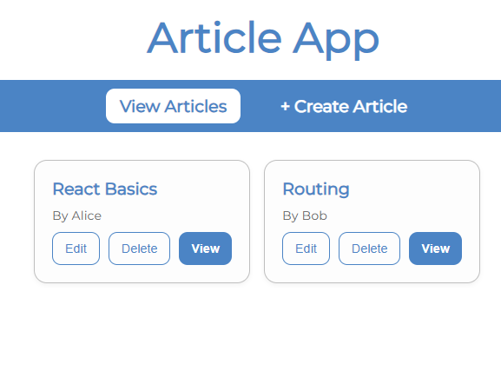

The project already works as we provide fake data (mock repository).

*Let’s understand in detail the back and front ends.*

***FRONT-END***

**Q2 - Look at ArticleForm**

How does the component know whether to create a new article or update an existing one?

It checks if an article ID is present (e.g., from route params); if yes, it updates, otherwise it creates.

Why is the **useParams** **hook** used in this component? What value does it provide when isEdit is true?

useParams gets the article ID from the URL; when isEdit is true, it provides the ID of the article to edit.

Explain what happens inside the **useEffect** hook. When does it run, and what is its purpose?

It runs on mount or when the ID changes; it fetches article data to prefill the form if editing.

**Q3 - Look at the ArticleList**

How are the three promise states (loading, success, and error) handled in the fetchArticles function?

By setting state: loading shows a spinner, success displays articles, error shows a message.

What is the role of the ArticleCard component, how does it communicate with the parent ArticleList?

ArticleCard displays a single article; it receives data and callbacks as props from ArticleList.

***BACK-END***

**Q4 - Why 3 layers ?**

The backend is composed of the below 3 layers : routes, controllers and repository :

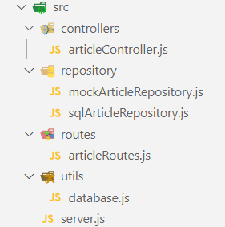

Describe the **responsibility** of each **layer** by completing the table below:

|  |  |
| --- | --- |
| LAYTER | RESPONSABILITIES |
| Routes | Handle HTTP requests and map them to controllers. |
| Controller | Process input, apply logic, and call repository. |
| Repository | |  |  | | --- | --- | | y | Interact with the database or data source. | |

**Q5 -**  **Implement the database connection**

Here are the files you need to update to **connect the backend to the database**:

|  |  |
| --- | --- |
| FILE | RESPONSABILITIES |
| /.env | securely store your MySQL database credentials |
|  |  |
| /utils/ database.js | Holds the **MySQL connection setup** logic  *Responsible for creating and exporting a* ***connection******pool*** *that other parts of the application can use.* |
| /repository/sqlArticleRepository.js | Provides **a clean, reusable interface** to interact with the articles table in your **MySQL database**.  *Encapsulates all the SQL queries related to articles and exposes them as functions that the rest of your application can call.* |

Here is what you need to do:

* **.env file**

Create a .env file to securely store your MySQL database credentials.

*See* [*https://www.npmjs.com/package/dotenv*](https://www.npmjs.com/package/dotenv)

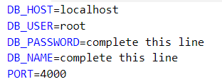

* **utils/database.js** 
  + Create a **MySQL connection pool** using the credentials from the .env file.

<https://sidorares.github.io/node-mysql2/docs#using-connection-pools>

* + Export this connection pool so it can be used by other modules in the project.
* **repositories/sqlArticleRepository.js**

Implement the following functions to interact with the articles table in the database:

getAll() — fetch all articles

getById(id) — fetch one article by ID

create(article) — insert a new article

update(id, article) — update an existing article

remove(id) — delete an article by ID

Use the connection pool from database.js to **execute the SQL queries** inside these functions.

*As an example, to implement getAll() :*

export async function getArticles() {

  const [rows] = await pool.query("SELECT * FROM articles");

  return rows;

}

**Q6 -**  **Test the endpoints**

To test the implementation of MySQL repository (*create, update, remove, get articles…)*

* First, perform tests using a **REST API client** (thunder or postman)
* Then, run the **front-end project** and asset the views work properly

# EXERCISE 3 – Handle **Journalists**

*For this exercise, you continue on the previous exercise code.*

Now, users want to see **who wrote each article** to better understand the source.

* You will need to update the app, so the article page shows the **journalist’s name and info.**
* You will need to provide a journalist view, showing all articles written by a specific journalist.

**Database**

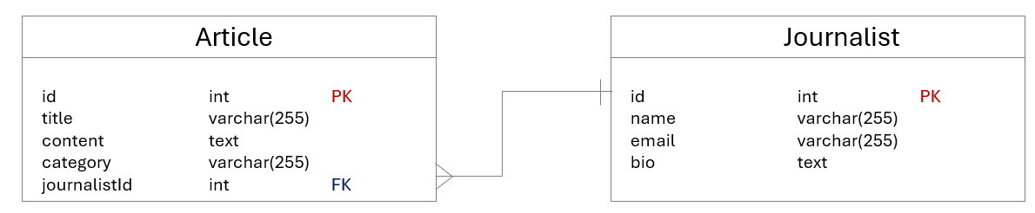

*Update your database structure to handle the journalist table*

* Create **journalists table** with fields: id, name, email, bi
* Update **articles table** to include journalist_id foreign key
* **Populate the database** with some fake data

**Back End**

* Implement **repository** methods:
  + Fetch articles with joined journalist name (using **SQL JOIN**)
  + Fetch all articles written by a specific journalist name (using **SQL JOIN**)
* Add **controller** functions:
  + Get all articles by journalist ID
* Define **new API routes**:
  + GET /api/articles/:id article + journalist name.
  + GET /api/journalists/:id/articles articles list by journalist.

**Front End**

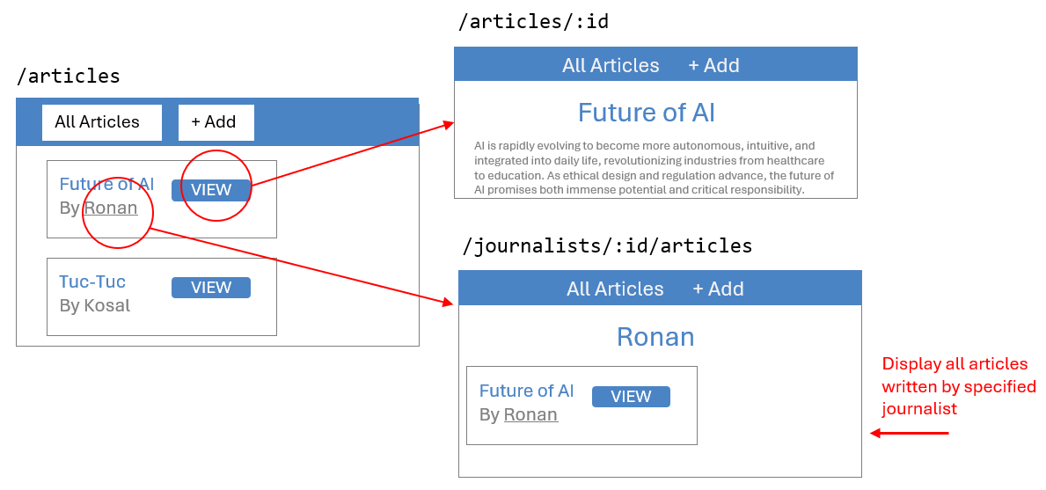

*An additional view shall display all articles written by the specific journalist*

* Update **Article Details page**:
  + Display journalist name alongside the article.
* Create **Journalist Articles List page**:
  + Display all articles by selected journalist.
* Add navigation:
  + From Article Details page, allow users to click journalist name to view **that journalist’s articles.**
* Update API calls:
  + Fetch combined article + journalist data.
  + Fetch articles filtered by journalist ID.

# EXERCISE 4 – Handle **Tags BONUS**

*For this exercise, you continue on the previous exercise code.*

Now, users want to easily **assign tags to articles**.

The users can then filter articles by selecting different tags.

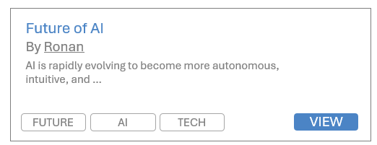

You will need to add categories to articles and let users filter the article list by selecting a category.

Database

* Create a new **table** Category (id, name).
  + *What kind of relationships do we have between articles and categories?*

**Back End:**

* Implement repository methods to:
  + Retrieve all categories.
  + Retrieve all articles filtered by category, using JOIN to include category name.
* Add a new API endpoint to get articles by category ID.

**Front End:**

* Add a **multiple categories filter UI component** on the **article list page** (multiple choice dropdown, chipset selector).
* When categories are selected, fetch and display only articles in those categories.
* Display categories names alongside articles in the list.